Ion Patrascu, Smarandache Geometries (or Hybrids), Octogon Mathematical Journal,
Vol. 31. No. 2, 966-969, October 2023.

Smarandache Geometries (or Hybrids)

Ion Patrascu
Colegiul National Fratii Buzesti
Craiova, Romania

Starting from 1995, Smarandache introduced Neutrosophy as a generalization of Dialectic, because in Neutrosophy it is about the dynamics of opposites but also of the neutrals between them. Whereas in Dialectic it is only about the dynamics of opposites.
In the real world there are many neutrosophic triplets of the form (<A>, <neutA>, <antiA>), where <A> is an entity, while <antiA> is its opposite, and <neutA> is the neutral (indeterminate) part ) among them.
E.g: (positive, neutral, negative), (victory, tie, defeat), (true, indeterminate, false), etc.
More generally, we have (Structure, NeutroStructure, AntiStructure) in any field of knowledge.
In general, by NeutroSofication, Smarandache extended any classical Structure, regardless of domain of knowledge, to a NeutroStructure, and by AntiSofication to an AntiStructure.
A classic Structure, in any field of knowledge, is composed of: a non-empty space, populated by some elements, and both (the space and all the elements) are characterized by some relationships between them (such as: operations, laws, axioms), properties, functions, theorems, lemmas, consequences, algorithms, diagrams, hierarchies, equations, inequalities, etc.), as well as by their attributes (size, weight, color, shape, location, etc.).
A particular case is the triplet (Geometry, NeutroGeometry, AntiGeometry).
A (classical) Geometry structure has all axioms completely (100%) true.
A NeutroGeometry structure has some axioms that are only partially true, partially indeterminate, and partially false (and no axiom is totally (100%) false to distinguish it from AntiGeometry).
Whereas an AntiGeometry structure has at least one axiom that is totally (100%) false.

Smarandache Geometry (or Hybrid Geometries)
An axiom is said to be smarandachely negated if in the same space the axiom behaves differently (ie, validated and invalidated; or only invalidated, but in at least two distinct ways). Therefore, we say that an axiom is partially negated or there is a degree of negation of an axiom.
A Smarandache geometry (or hybrid geometry) is a geometry that has at least one axiom negated in two different ways (1969).
Thus, as a particular case, the Euclidean, Lobachevsky-Bolyai-Gaussian and Riemannian geometries can be joined altogether, in the same space, by some Smarandache geometries. These latter geometries can be partly Euclidean and partly non-Euclidean.

Example of NeutroGeometry (or First Class of Smarandache Geometry (or Hybrids)
where an axiom is partly true and partly false in the same geometric space.
For example, there are two distinct points that determine a single line and two other distinct points that do not determine any line in the same geometric space.
Thus, Hilbert's postulate I.1. from the Axioms of Incidence, announced as follows:
"For every point P and every point Q not equal to P, there is a unique incident line with the points P and Q" becomes partly true and partly false:
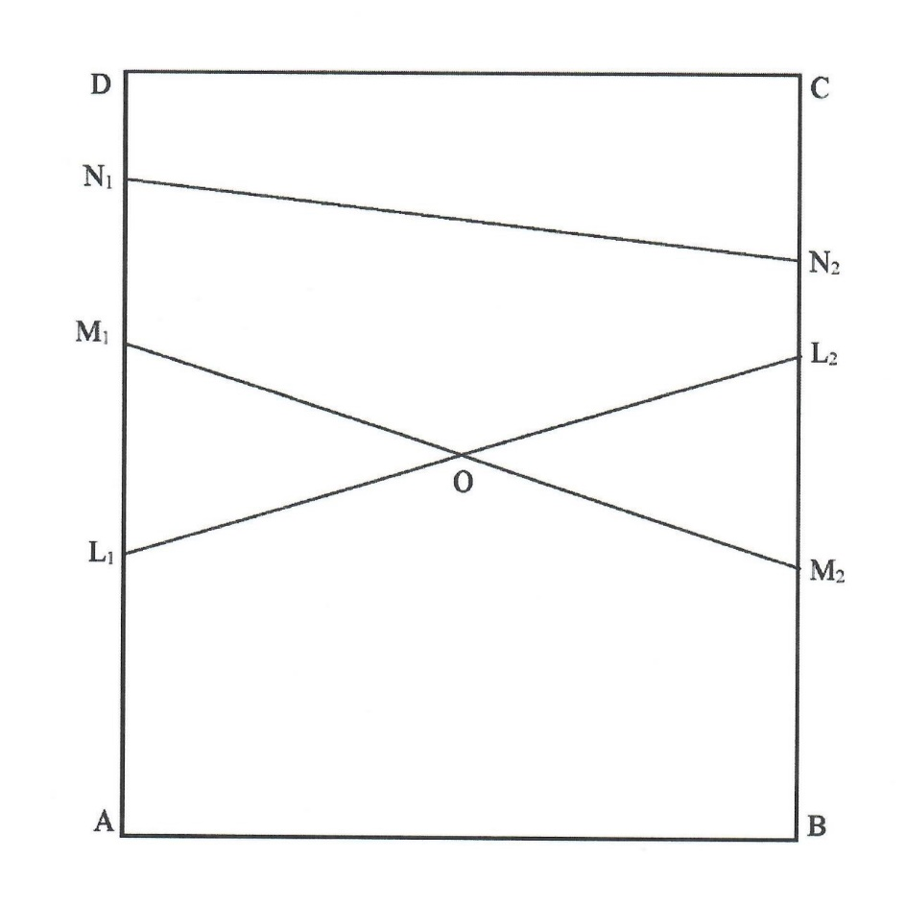
Geometrical Model 1

Suppose that the rectangle ABCD is a geometric space, where
"point" means any classical point on the sides AB and CD or inside this rectangle,
and "line" is any line segment joining a point on side AB to a point on side CD and passing through the center O of the rectangle.
For example, L₁L₂ is a line because it connects the point L₁ located on AB and the point L₂ located on CD and passes through the center O. Similarly for the line M₁M₂.
But N₁N₂ is not a line because it does not pass through the center O.

References:
1. Florentin Smarandache, NeutroGeometry & AntiGeometry are alternatives and generalizations of the Non-Euclidean Geometries, Neutrosophic Sets and Systems, vol. 46, 2021, pp. 456-477. DOI: 10.5281/zenodo.5553552, http://fs.unm.edu/NSS/NeutroGeometryAntiGeometry31.pdf
2. Carlos Granados, A note on AntiGeometry and NeutroGeometry and their application to real life, Neutrosophic Sets and Systems, Vol. 49, 2022, pp. 579-593. DOI: 10.5281/zenodo.6466520, http://fs.unm.edu/NSS/AntiGeometryNeutroGeometry36.pdf
3. Florentin Smarandache, Real Examples of NeutroGeometry & AntiGeometry, Neutrosophic Sets and Systems, Vol. 55, 2023, pp. 568-575. DOI: 10.5281/zenodo.7879548, http://fs.unm.edu/NSS/ExamplesNeutroGeometryAntiGeometry35.pdf
10. L. Mao, Smarandache Geometries & Map Theories with Applications (I), Academy of Mathematics and Systems, Chinese Academy of Sciences, Beijing, P. R. China, 2006, http://fs.unm.edu/CombinatorialMaps.pdf
11. Linfan Mao, Automorphism Groups of Maps, Surfaces and Smarandache Geometries (first edition - postdoctoral report to Chinese Academy of Mathematics and System Science, Beijing, China; and second editions - graduate textbooks in mathematics), 2005 and 2011, http://fs.unm.edu/Linfan.pdf, http://fs.unm.edu/Linfan2.pdf
12. L. Mao, Combinatorial Geometry with Applications to Field Theory (second edition), graduate textbook in mathematics, Chinese Academy of Mathematics and System Science, Beijing, China, 2011, http://fs.unm.edu/CombinatorialGeometry2.pdf
13. Yuhua Fu, Linfan Mao, and Mihaly Bencze, Scientific Elements - Applications to Mathematics, Physics, and Other Sciences (international book series): Vol. 1, ProQuest Information & Learning, Ann Arbor, MI, USA, 2007, http://fs.unm.edu/SE1.pdf
14. Howard Iseri, Smarandache Manifolds, ProQuest Information & Learning, Ann Arbor, MI, USA, 2002, http://fs.unm.edu/Iseri-book.pdf
15. Linfan Mao, Smarandache Multi-Space Theory (partially post-doctoral research for the Chinese Academy of Sciences), Academy of Mathematics and Systems Chinese Academy of Sciences Beijing, P. R. China, 2006, http://fs.unm.edu/S-Multi-Space.pdf
16. Yanpei Liu, Introductory Map Theory, ProQuest Information & Learning, Michigan, USA, 2010, http://fs.unm.edu/MapTheory.pdf
17. L. Kuciuk & M. Antholy, An Introduction to the Smarandache Geometries, JP Journal of Geometry & Topology, 5(1), 77-81, 2005, http://fs.unm.edu/IntrodSmGeom.pdf

