The Scientific World Journal
Applications of the NeutroGeometry and Smarandache Geometries in Real World
González-Caballero, E.¹
¹ Centre of Studies of Mathematics for Engineers, Technological University of Havana, Havana, 27 Calle 114 # 11901 e/ Ciclovía y Rotonda, Marianao, Cuba.
Correspondence should be addressed to Erick González-Caballero; erickgc@yandex.com

Abstract
NeutroGeometries are those geometric structures where at least one definition, axiom, property, theorem, among others, is only partially satisfied. In AntiGeometries at least some of these concepts are never satisfied. Smarandache Geometry is a geometric structure where at least one axiom has different characteristics. This paper offers examples in images of nature, everyday objects, and celestial bodies where the existence of Smarandechean or NeutroGeometric structures in our universe is revealed. On the other hand, a practical study of surfaces with characteristics of NeutroGeometry is carried out, based on the properties or more specifically NeutroProperties of the famous quadrilaterals of Saccheri and Lambert on these surfaces. The article contributes to demonstrating the importance of building a theory such as NeutroGeometries or Smarandache geometries because it would allow us to study geometric structures where the well-known Euclidean, Hyperbolic or Elliptic geometries are not enough to capture properties of elements that are part of the universe, but they have sense only within a NeutroGeometric framework. It also offers an axiomatic option to the Riemannian idea of Two-Dimensional Manifolds. In turn, we prove some properties of the NeutroGeometries and the materialization of the symmetric triad <Geometry>, <NeutroGeometry>, and <AntiGeometry>.

Introduction
Euclidean geometry dominated this branch of mathematics for centuries; it has been considered the only possible geometry [1-2]. Even today most school students take only Euclid's geometry as a subject. However, approximately in the eighteenth century began to develop what is known as non-Euclidean geometries [3-4]. This mastery of Euclid's geometry is due more than anything to the monumentality of his work "Elements" and to the way of approaching geometries formally based on definitions, axioms, and proofs. This formality is of vital importance because it is how mathematics in all its branches is still approached today [2].
Euclid's controversial fifth postulate establishes that if a straight line cuts two others and if on the side where the sum of the angles formed by the first line with the others is less than two straight angles, then the two lines necessarily intersect at a point by that side. This is equivalent to the fact that given a straight line then through any point outside it passes one and only one parallel. In the attempt by many mathematicians to prove this postulate from the other four, failures followed, which indicates that this postulate or axiom is independent of the others and that it can be replaced by a different axiom.
One way to demonstrate the practical validity of non-Euclidean geometries is before our very eyes, the planet earth is approximately a sphere and on its surface, it is not possible to establish a Euclidean geometry, this can be seen in the maps where it is necessary to alter the dimensions of some areas of the planet to impose a parallelism that is typical of a Euclidean plane and not of Spherical Geometry. Likewise, in Physics, everything seems to indicate that the universe is not exactly flat.
As a result of this, by historical order, after Euclidean geometry, hyperbolic geometry arose, where for each point outside a line two lines pass parallel to the first one, then elliptic or Riemannian geometry establishes the non-existence of parallelism between lines [5-6]. From these postulates, several geometric models emerged, which allowed us to validate the new theories. Within Hyperbolic Geometry there are the models of the upper half plane of Poincaré, the Poincaré disk, and the Beltrami-Klein disk [7-9]. Within elliptical geometry emerged the model of the sphere and the projective model [1].
An idea that was even more revolutionary was that of Riemann, who proposed that from any Euclidean surface it is possible to define a Geometry, where angles and metrics are defined internally and they exist locally, without the need to create a general axiomatic as in the previous theories [2]. This is how differentiable two-dimensional Riemannian manifolds are defined, such that under certain conditions they have Euclidean characteristics in the neighborhood of each point [1]. That is why there exist as many two-dimensional geometries as there are surfaces and this is also valid for higher dimensions.
This assertion starts from the fact that each fundamental type of geometry, namely, Euclidean, hyperbolic and elliptic, has been associated with the Gaussian curvature of the surface on which they are defined [10]. Rather this has to do with the sign of the curvature. It is known that if K denotes the Gaussian curvature of a surface, then if K = 0 on the two-dimensional surface, a Euclidean-like geometry will develop. On the other hand, when K<0, which is characteristic of saddle-shaped surfaces, then the geometry on it will be hyperbolic. Finally, when K>0, an elliptic geometry will occur on the surface as in the terrestrial sphere.
However, Riemann realized that these classical two-dimensional geometries depend on the fact that the surfaces have constant curvature, which is not observed in the geometric shapes that surround us. Each surface and therefore each space or hyperspace contains combinations of different curvatures and this makes it impossible to build a unique geometry, since the Euclidean, the hyperbolic, and the elliptic are special cases that do not have to be considered as preferential over others. Logically what Riemann says implies that there is a total uncertainty about the type of geometry according to the classical way of approaching this branch of mathematics, where local behavior in terms of metrics is the only practical way of approaching geometry, abandoning the axiomatic that emerged from Euclid, entering in the branch of Differential Geometry [1, 10].
In line with what Riemann said, the Mixed Geometries of Smarandache appear later, where the traditional axiomatic is not abandoned, but it is admitted that at least one axiom contains characteristics of different geometries, that is, a part of the geometric objects satisfies a certain type of geometry, another part satisfies another, and so on [11]. This means that in the plane, for example, one region of the surface satisfies Euclid's axiomatic, another part is hyperbolic, and a third one is elliptic. This constitutes a less radical approximation compared to the Riemannian’s for the changes of curvature within the same surface.
Later, Smarandache himself defined the so-called NeutroGeometries based on the philosophical-mathematical theory of Neutrosophy, where indeterminacy, contradiction, imprecision, paradox, inconsistency, ignorance, and neutrality, form a fundamental part of those studied. In NeutroGeometries at least one axiom, definition, theorem, proposition, property, and so on is only partially satisfied, while in AntiGeometries at least one axiom, definition, theorem, proposition, property, and so on, is not satisfied in any case [12-13]. There are still few models of NeutroGeometries and a theory with yet the development reached by the precedent others.
In this paper, the author aims to support the theory of NeutroGeometries and Smarandache geometries with practical examples. For this end, firstly figures of physical, natural, and artistic objects will be shown, where the existence of surfaces that satisfy NeutroGeometry are illustrated. We will also construct surfaces where NeutroGeometries take place; we will study how the axioms are manifested in these surfaces. For the study, we will rely on the characteristics of the Saccheri and Lambert quadrilaterals within different zones of these surfaces [14]. We choose these quadrilaterals because they are precise indicators of the type of geometry that is defined on the surface, especially the angles of the “summit” of the quadrilateral. We will show that, as occurs in the Neutrosophic theory, while there are areas of these surfaces where certain geometry is satisfied, and in others they are not, also there are some indeterminate areas, which implies the existence of symmetry in the representation of the NeutroGeometries.
This paper is divided into section 2 where some important concepts are explained to understand the essence of this article, such as the notions of non-Euclidean geometries, Saccheri and Lambert quadrilaterals [5], the relationship of the Gaussian curvature sign with the three types of basic geometries, as well as the definition of NeutroGeometry or Smarandache Geometry. Section 3 will bring us closer to real examples and the analysis of examples of surfaces where the NeutroGeometries or Smarandachean geometries hold, through the analysis of the Saccheri and Lambert quadrilaterals within these surfaces. Finally, section 4 is dedicated to Discussions and section 5 draws the Conclusions of this paper.

Preliminaries
First of all, it is necessary to begin with a brief exposition of Euclid's postulates, the famous "Elements" consists of 13 books and therefore it would be impossible to include all these details in this article [1-2]. Euclid wrote the concepts of his geometry, the axioms, and his five postulates, in addition to the theorems that are known in elementary geometry courses. That is why we will include only the five postulates or axioms of Euclidean geometry, which are the following:
- A straight line can be drawn through any two points.
- Given any segment, it can be continuously lengthened indefinitely.
- From any center, a circle of arbitrary radius can be drawn.
- All right angles are equal.
- Whenever a straight line, when intersecting two others, forms on the same side with internal angles whose sum is less than two straight angles, then such two straight lines will necessarily intersect on that side.
This fifth postulate is equivalent to the following statements [1, 14]:
- For each point outside a straight line, there is only one parallel to it.
- When two parallel lines intersect a third one, they form equal corresponding angles.
- The sum of the interior angles of a triangle is equal to two right angles.
- Points located on the same side of a given line, at the same distance from it, form a line.
- Given two parallel lines, the distances of the points from one of them to the second one are bounded.
- There are triangles with arbitrarily large areas.
- There are similar triangles.
At present, to rigorously study Euclidean geometry, it is necessary to refer to David Hilbert’s axioms on such geometry, where the axiomatic weaknesses shown by the former are corrected by D. Hilbert. In this case, it would be necessary to study the 21 axioms proposed by him. However, for this paper, it is sufficient to have the 5 aforementioned postulates, and an additional axiom used by Euclid only implicitly, which is today known as Pasch's axiom, and this says as follows [1-2]:
- A line that intersects one edge of a triangle and avoids all its three vertices must intersect one of the other two edges.
Absolute Geometry or Neutral Geometry is known as the geometry that satisfies only postulates I-IV [14]. Therefore Euclidean Geometry is a particular case of Absolute Geometry.
Hyperbolic geometry is defined as the one that satisfies the first four postulates and the fifth is replaced by the following [15]:
- Given a line and an exterior point, there are two lines parallel to it passing through the point.
In this geometry, the principles of congruence of triangles are maintained, in addition to including one more which is AAA, which says that if two triangles have congruent interior angles, then the triangles are congruent. In this case, there is a one-to-one relationship between the angles of the triangle and the length of its sides; therefore in this geometry, there cannot be triangles with equal angles that are not congruent.
Another result of interest is that the sum of the interior angles of a triangle is strictly less than two right angles. Therefore, the sum of the interior angles of a quadrilateral is strictly less than four right angles.
The relationship between side and angle in hyperbolic geometry implies that the area of a triangle is defined from its angles and is equal to $A_{T}=π-\left(α+β+γ\right)$, that is, π minus the sum of its interior angles [16].
An example of a surface with hyperbolic geometric features is the pseudosphere, which is the surface of revolution generated from the curve called tractrix. Figure 1 shows its shape and how the fifth postulate of hyperbolic geometry is fulfilled.
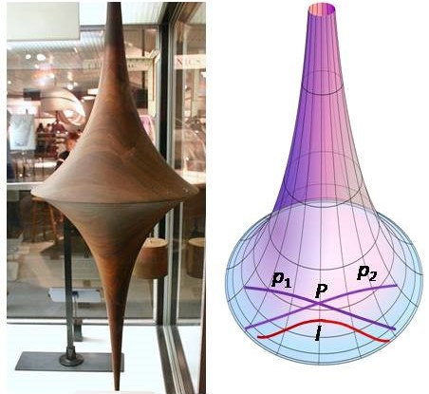
Figure 1. Pseudosphere (on left). On the right, there is a pseudosphere, the line l (colored in red), and its two parallels p₁ and p₂ (colored in violet ) passing through a point P. Source: http://commons.m.wikipedia.org (the image on the right was slightly modified from its original design).
Figure 1 contains a pseudosphere on the left and the same surface on the right, where there is a line and two parallels; moreover, it is a classical result that if l has two parallels by P then there are an infinite number of them.
The third option of geometry is called Elliptic Geometry or Riemann’s Geometry [6]. In this geometry the fifth postulate is replaced by the following:
- No parallel line passes through a point outside a given line in the plane.
The second postulate must also be modified so that it is not possible to infinitely lengthen a given segment, because in this case, the so-called lines are great circles within a sphere.
In this geometry, the AAA principle must also be included, since two triangles with congruent internal angles are themselves congruent. Also, the sum of the interior angles of a triangle is strictly greater than two right angles and the sum of the interior angles of a quadrilateral is strictly greater than four right angles. The area of a triangle in this geometry is $A_{T}=α+β+γ-π$.
Another axiom to modify is one of the axioms explicitly defined by Hilbert, called “betweenness”, where due to the circular nature of the lines of this geometry it is essential to redefine when a point within a segment is located between two other points. This is remedied by redefining this relationship between four points instead of just three.
A model of this geometry is the double elliptic plane, which differs from the sphere in that each pair of antipodal points is considered a single point, thus satisfying the first axiom. That is, inside the sphere, the lines are the circumferences with the center and radius coinciding with the center and radius of the sphere. Since an infinite number of great circles pass through each pair of opposite or antipodal points within a great circle on the sphere, then the pair of antipodal points within the sphere is defined as a single point of the model. In this way, the distance between two points of the model is defined as the minimal distance within the spherical geometry of the distances between the combinations of pairs of antipodal points, see Figure 2 and note that there are no parallels between lines through any point.
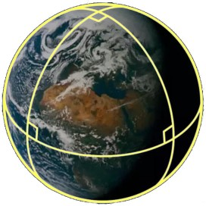
Figure 2. Spherical model of elliptic geometry. In yellow lines, we can see great circles that are the "lines" of this model. Source: http://www.quora.com.
It has been found that there is a close relationship between these three geometries and the Gaussian curvature of the Euclidean surface on which the geometry is defined [1, 10]. The Euclidean surface with Gaussian curvature K = 0 and which is constant corresponds to the Euclidean planes and is also called Parabolic Geometry. When the surface has constant Gaussian curvature with K<0, it is said to be a hyperbolic geometry, the tangent planes at each point of such a surface cut the surface in various curves. Finally, if the Gaussian curvature is constant with K>0, it is said we define an elliptic geometry and in that case, the tangent planes at each point to the surface have no intersection with the surface except at the point of tangency.
The surface of the right circular cylinder is an example of a surface with parabolic geometry, the pseudosphere is a surface with K = -1, and the double elliptic plane is a surface with $K =\frac{1}{r^{2}}>0$, where r is the radius of the sphere.
However, for the first time, Riemann admitted that Euclidean surfaces can have different Gaussian curvatures in terms of magnitude and sign, which is why there are as many geometries as surfaces. It only remains for us to define geometries with inner angles and metrics that are locally equivalent to Euclidean geometry. This gave way to the development of the branch of mathematics known as Differential Geometry [1-2, 10]. Thus, from the axiomatic point of view, the relationship between the three basic types of geometries and the Gaussian curvature has been well defined.
This article aims to carry out a logical-axiomatic approach to geometries, rather than from the solution given by Riemann through the so-called differentiable two-dimensional Riemannian manifolds or the S-manifolds studied by H. Iseri ([17]). We will now focus on explaining the notion of Saccheri and Lambert Quadrilaterals which are very useful to determine which type of geometry is within the three main ones we deal with.
To build a Saccheri quadrilateral in any of the three geometries we start from any segment $\overline{AB}$ called "base", on the same side concerning $\overline{AB}$ two segments are erected perpendicular to it, denoted by $\overline{BC}$ and $\overline{AD}$, both of the same length called "legs". Then, points $C$ and $D$ are joined in the segment $\overline{CD}$ and this is called "summit". The angles $∠BCD$ and $∠ADC$ are called "summit angles". It is known from classical proofs that $∠BCD$ and $∠ADC$ are congruent, in addition to being right in the Euclidean plane, acute in the hyperbolic plane, and obtuse in the elliptic plane. That is, the characteristics of the "summit angles" of the Saccheri quadrilateral are related to the type of geometry on which this quadrilateral is defined, see Figure 3.
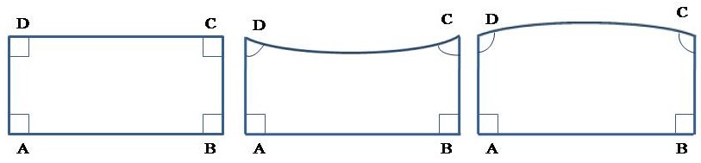
Figure 3. Saccheri quadrilaterals from left to right, in Euclidean, hyperbolic, and elliptic geometry. Source: the author.
On the other hand, a Lambert quadrilateral is a quadrilateral with three right angles. The fourth angle will be right if it is Euclidean geometry, acute if it is hyperbolic geometry, and obtuse if it is elliptic geometry, see Figure 4.
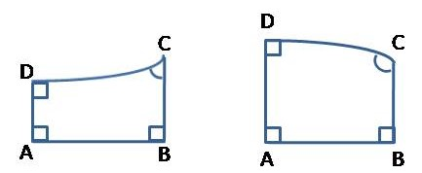
Figure 4. Lambert quadrilaterals from left to right, in hyperbolic and elliptic geometry. Source: the author.
The Saccheri and Lambert quadrilaterals are not equivalent to each other, although if a Saccheri quadrilateral is divided by the perpendicular bisector to the base segment, two Lambert quadrilaterals will be obtained.
For the Saccheri quadrilateral in hyperbolic geometry, the length of the summit is greater than the length of the base, while in elliptical geometry the opposite occurs, and in Euclidean geometry they are equal.
More recently Smarandache Geometry appeared, “A Smarandache Geometry is a geometry which has at least one Smarandachely denied axiom, i.e., an axiom behaves in at least two different ways within the same space, i.e., validated and invalidated, or only invalidated but in multiple distinct ways and a Smarandache n-manifold is an n-manifold that support a Smarandache Geometry” [12, 17, 19].
An example of Smarandache Geometry is a two-dimensional geometry where some elements (lines and points) satisfy Euclid's fifth postulate, another set satisfies the axiom of two parallels or more of hyperbolic geometry, and a third set satisfies the axiom of non-parallelism between lines of elliptic geometry.
Two more recent concepts that generalize the concept of Smarandache Geometry are those of NeutroGeometry and AntiGeometry, also defined by F. Smarandache [12]. In NeutroGeometry, at least one axiom, definition, theorem, proposition, property, among others, is satisfied by some elements of the space, although not by all. On the other hand, AntiGeometry contains an axiom, definition, theorem, proposition, property, among others that are not satisfied by any element of the space.
A model of NeutroGeometry and in turn of Smarandache Geometry was defined by Bhattacharya [18], as can be seen in Figure 5.
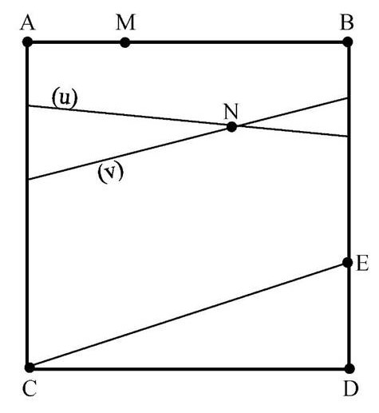
Figure 5. Bhattacharya’s model of Smarandache Geometry and NeutroGeometry. Source: [18].
The geometric space is formed by the square $ABCD$, where the points are the usual ones, including those of the border. The lines are the Euclidean line segments that join a point on the segment $\overline{AC}$ with one point on the segment $\overline{BD}$, this includes the lines (u), (v), $\overline{AB}$, $\overline{CD}$, and $\overline{CE}$. The concepts of parallelism and the intersection of two lines are the usual ones.
Given the line $\overline{CE}$, two parallel lines pass through point $N$ outside it, (u) and (v). A single line $\overline{AB}$ passes through point $M$ and is parallel to it, while there is not any parallel to $\overline{CE}$ passing by point $D$.
That is why this space is a NeutroGeometry or Smarandachean’s since the Euclidean parallelism axiom is satisfied by a set of elements, the hyperbolic geometric axiom is satisfied only by another set of elements and the non-parallelism axiom of elliptic geometry is satisfied by the third set of elements.
On the other hand, a model of AntiGeometry is hyperbolic geometry, where Euclid's fifth postulate is not satisfied by any element of the space.
The difference among Smarandache Geometry, NeutroGeometry, and AntiGeometry is subtle. A Smarandache Geometry (or Hybrid Geometry) is a geometry which has at least one smarandachely denied axiom [or theorem, proposition, etc.], i.e., in the same space the axiom behaves differently (i.e., validated and invalided; or only invalidated but in at least two distinct ways).
In the case when the axiom is validated and invalidated, Smarandache Geometry is a particular case of NeutroGeometry. While in the case when the axiom is only invalidated Smarandache Geometry is a particular case of the AntiGeometry [11-13].
Interestingly, there are also Smarandache manifolds or S-manifolds defined by H. Iseri, where triangular tessellations of the space are obtained, and each triangle is considered a disk of the S-manifold, thus in some parts of the structure, Euclidean properties related to the parallelism between lines are defined, in other ones hyperbolic properties materialize, and in a third part, elliptic properties are defined.
It should be noted that the axiomatization understood by F. Smarandache from the logical point of view can be subjected to a process of neutrosophication, where the concept C (postulate, axiom, theorem, property, function, transformation, operator, theory, and so on), can be divided into three elements, $〈C〉$ is the concept itself that is satisfied by 100% of the elements of the space, $〈AntiC〉$ that is not satisfied by any element of the space, and $〈NeutC〉$ that is neither $〈C〉$ nor $〈AntiC〉$; or $〈C〉$ is satisfied by some elements, not satisfied by others, and is indeterminate for others. That is why within this new theory there will be NeutroAxioms, NeutroDefinitions, NeutroFunctions, NeutroProperties, NeutroConcepts, among others.

NeutroProperties in Smarandachean surfaces
This section contains a practical analysis of Saccheri and Lambert quadrilaterals properties on surfaces with NeutroGeometry or AntiGeometry characteristics. The meaning of this study is that this constitutes proof of the usefulness of any theoretical approach to NeutroGeometries and AntiGeometries, it is the search for real objects that support the utility of this approach and that respond to the characteristics proposed by F. Smarandache.
In subsection 3.1, annotated images of nature, objects of daily life, or astronomy appear where examples of surfaces that contain characteristics of NeutroGeometries can be seen. Then, in subsection 3.2 we carry out the promised practical analyzes by studying the properties of the Saccheri and Lambert quadrilaterals on a surface constructed for these purposes.

3.1. Smarandache surfaces in the universe, nature, and craft objects.
One of the reasons why Euclidean geometry has gained prestige is the wide practical application it has found over the centuries of its development. In this subsection, we will discuss how there are objects, animals, celestial bodies, among others whose surfaces can be described as NeutroGeometries. Thus, we demonstrate that an axiomatic approach to geometrical problems is possible, without the need to reach the radicalism shown by Riemann in his works on two-dimensional manifolds, where local and non-axiomatic studies of geometry are carried out. Although there is no doubt that Riemann’s idea is convenient, due to the impracticality of dealing with so many possible geometries in objects in the universe. We must also highlight the importance of manifolds in Smarandache geometries developed by H. Iseri.
Figure 6 contains images of two sea creatures, the jellyfish and the octopus.

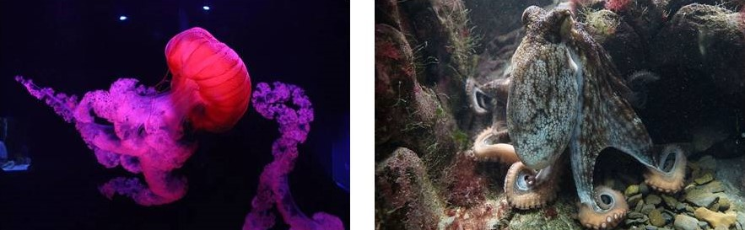
Figure 6. Images of two marine animals: the jellyfish (on the left), and the octopus (on the right). Source: http://www.pixabay.com
It can be seen in Figure 6 that there is an evident difference in curvature between the umbrella shape of the upper portion of the jellyfish or the head of the octopus and the membranes that cover the tentacles of both animals. If both animals are analyzed, the first part has positive curvature, while their membranes have negative curvature. This can be checked by drawing triangles on both portions of the surfaces and determining the sum of their internal angles. That is why the first portion of both creatures responds to an elliptical geometry, while the second one responds to a hyperbolic geometry; the entire surface is Smarandache Geometry and Euclidean AntiGeometry. In each case, this is an approximation, since due to the flexibility of the bodies of the two animals the values of the curvatures can change, however, the sign hardly changes, although constant curvatures are not guaranteed even when the animals are still in the same position.
Figure 7 shows images of artificially created objects in an industrial or artisanal way.

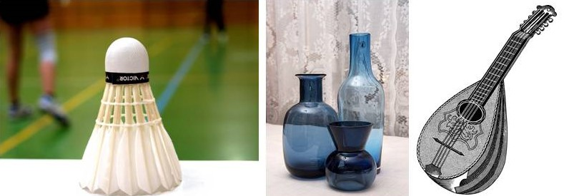
Figure 7. Images of artificial objects: badminton ball (on the left), glass vases (in the center), and old lute (on the right). Source: http://www.pixabay.com
The top of the badminton ball is a hemisphere, the black belt is a cylinder, and the back is formed by structures imitating bird feathers, which placed together form a negative Gaussian curvature surface. The surface of the ball as a whole is divided into three well-defined sections where there is an elliptical geometry at the top, followed by Euclidean geometry and culminating in a surface with hyperbolic characteristics.
The central part of Figure 7 is constituted by a composition of three glass containers, where the two ones on the left and the center are those with the most marked Smarandachean characteristics. The one on the left has a peak similar to the central part of the pseudosphere in Figure 1, followed by a cylinder that is a type of Euclidean manifold of constant Gaussian curvature equal to 0, while it is supported by a portion roughly similar to an ellipsoid, which is of positive curvature. The central vessel is formed by a cone that corresponds to Euclidean surface characteristics and this is supported by a convex ellipsoid-shaped surface.
The right part in the figure is an old lute, the frontal part is flat, and the strings can be considered segments of lines, which are parallel to each other, and it corresponds to Euclidean geometry. The back of the instrument is a domed surface of positive curvature, though not constant. That is why the total area cannot be studied with the help of a single axiom of parallelism.
To finish the figures containing elements with Smarandachean geometric feature surfaces see Figure 8.

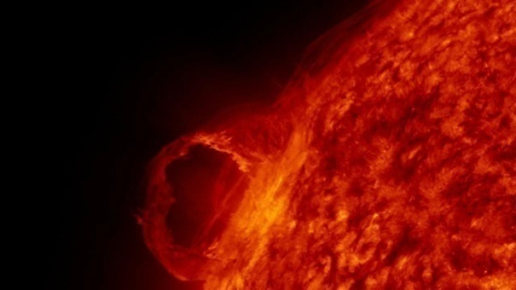
Figure 8. Solar surface. Source: http://www.pixabay.com
Figure 8 shows the solar surface that is spherical and therefore corresponds to spherical geometry more than elliptical, however in a closer view some deformations that correspond to hyperbolic geometry are seen in some parts of its surface.

3.2. Study of a designed Smarandache surface
In subsection 3.1 we saw different elements, like manufactured objects, animals, and the solar surface, where two or three subregions are identified, such that in each of them the axiomatic of a different type of geometry is fulfilled within the three fundamental geometries. This was the first step to demonstrate the validity of NeutroGeometries since the appearance of real objects justifies the usefulness of studying these geometries, where these surfaces constitute real models of them.
Below we offer a surface designed by the author of this paper, which is very similar to the surface of one of the vases that appear in Figure 7. We represent this design schematically in two dimensions, although we study it as a two-dimensional surface embedded in the three-dimensional Euclidean space. Let us call such a surface S, as it appears in Figure 9.

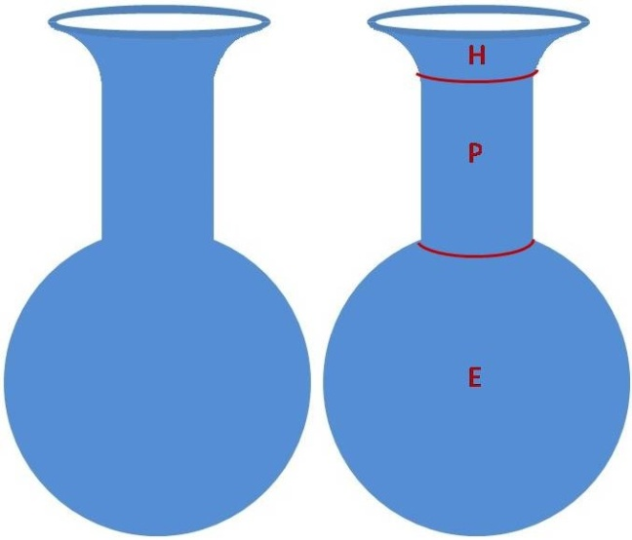
Figure 9. Surface S under study and built by the author. On the right, the surface appears partitioned into three pieces. Source: the author.
This surface is made up of three regions with the exclusive characteristics of each of the three types of geometries. The upper part called H for hyperbolic is congruent to the shape of the central part of the pseudosphere; the middle part is a cylinder called P for parabolic; and the base is spherical called E for elliptic. So we have $S=H∪P∪E$.
This analysis is enough to classify S as a surface corresponding to a NeutroGeometry or with a NeutroAxiom of parallelism, which is articulated in a total surface where some elements satisfy the characteristics of any of the three geometries and others do not. That is why the Saccheri and Lambert quadrilaterals will have the characteristics shown in Figures 3 and 4 depending on whether they are drawn exclusively inside H, P, or E.
Nevertheless, we will continue studying the imprecise zones that form part of the border between two contiguous sections of the surface and that in Figure 9 on the right are segments of lines drawn in red. The Saccheri or Lambert quadrilaterals in this border zone present some interesting properties or NeutroProperties, as we will see next. First of all, let us define what Saccheri and Lambert quadrilaterals are in a NeutroGeometry and how they would be built, taking as a model the surface of the body that appears in Figure 9.
Before reaching the definitions, we must note that the segments of the line that will be drawn on a surface like the one in Figure 9 connect the points, and these segments are contained in a geodesic, where for simplicity a geodesic line will be considered to be the one with the smallest length joining two points within the surface. In the case of the points in the H region, the segments will follow the lines of hyperbolic geometry on the pseudosphere; on the surface P are the segments contained in Euclidean straight lines; while over region E, the lines are the great circles. In particular, when a segment is drawn that connects two points that are in two different regions, the geodesic line may be the union of an arc of the circumference with a straight line segment and also a line on the pseudosphere, in this case, the geodesic line will be constituted by the union of segments of geodesics according to the corresponding geometry.
Definition 1. A generalized Saccheri quadrilateral over a surface that defines a NeutroGeometry is constructed from a segment $\overline{AB}$ called “generalized base” contained within a geodesic of the surface. On the same side for $\overline{AB}$ stand two segments perpendicular to it called “generalized legs” that are also part of some geodesic on the surface, such that both “generalized legs” have equal Euclidean lengths, let us denote them by $\overline{BC}$ and $\overline{AD}$. Finally, let us draw the segment $\overline{CD}$ that we will call a “generalized summit”. Similarly to the classical definition these angles, $∠BCD$ and $∠ADC$ are called “generalized summit angles”.
Definition 2. A generalized Lambert quadrilateral over a surface that defines a NeutroGeometry is constructed from four points $A$, $B$, $C$, and $D$, such that the segments $\overline{AB}$, $\overline{BC}$, $\overline{AD}$ and $\overline{CD}$ satisfy that three angles of the quadrilateral are right angles. These segments are drawn through the geodesics of the surface.
Remark 1. The generalized Saccheri and Lambert quadrilaterals in subregions of the surface where only one of the three geometries holds coincide with the definitions and properties of the original Saccheri and Lambert quadrilaterals. However, the opposite is not true in general, that is, there are generalized Saccheri and Lambert quadrilaterals that are not the ones originally defined by these two mathematicians. We will make sure of this later.
See Figure 10, where generalized Saccheri and generalized Lambert quadrilaterals appear on the two borders between the subregions H-P and P-E of Figure 9.

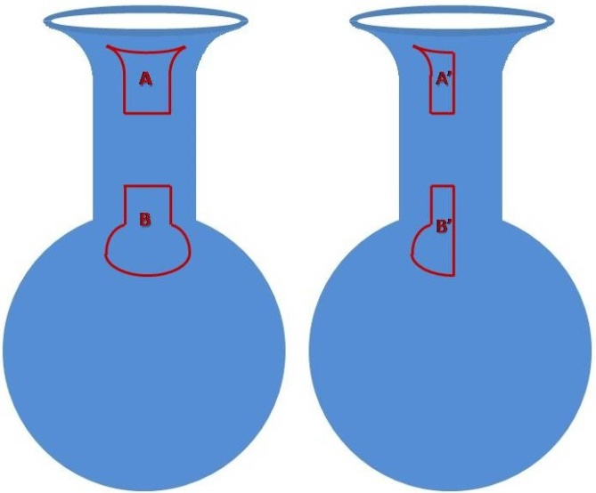
Figure 10. Generalized Saccheri (A and B) and Generalized Lambert (A' and B') quadrilaterals on the surface S. Source: the author.
As can be seen in Figure 10, the edges of A, B, A', and B' that cut the borders between H and P or between P and E contain geodesics that combine two different types of geodesics, depending on the region where they are found. The segments through H and P contain one segment in the form of a Euclidean straight line, while the other piece of the segment is in the form of a line within a pseudosphere. On the other hand, the segments that pass through the boundary between P and E have one segment contained in a straight Euclidean line and another segment that is part of an arc of a great circle. Both A and B, as well as A' and B' in Figure 10, satisfy the aforementioned properties of the classical Saccheri and Lambert quadrilaterals; such as that both “generalized summit angles” are congruent. It can also be seen that each generalized Saccheri (Lambert) quadrilateral is the union of the two Saccheri (Lambert) quadrilaterals, each within the regions corresponding to H, P, and E.
However, all of the above properties are satisfied only due to the way the surface S was defined, this is not the case in general. Although the same properties are maintained in S like invariance if a horizontal translation of these geometric figures is carried out, on the contrary, when a vertical translation of any A, B, A', B' is carried out, the new quadrilaterals obtained are not congruent to those above in the classical sense of congruence. That is if the edges of the quadrilateral are formed by the union of two segments defined from two geodesics of different geometries when they are translated vertically through S in such a way that the border between two different regions continues to cut the quadrilateral, then depending on the direction of translation, the particular segment type must be changed.
To illustrate this operation let us take the Saccheri quadrilateral A as an example. If it is moved vertically towards the direction of its base, each generalized leg will necessarily have to be modified, the length of the Euclidean segment of each generalized leg would be lengthened and the length of the hyperbolic segment would be shortened for every one of them. Even if it was desired to maintain the same length of the initial generalized leg, it would be necessary to take into account that when a length s is the magnitude of the translation, to maintain the length of the generalized leg, the Euclidean segment would have to be stretched, if one takes into account that a hyperbolic segment that joins two points will be greater in Euclidean distance than the Euclidean segment that joins such points.
On the other hand, the generalized base at region P of quadrilateral A would not be affected by the properties of Euclidean geometry, whereby lengthening straight parallel lines, the distances between their points will be the same, that is why the side of A in P will remain the same in this case. However, the identical property will not occur in H, where the length depends on the angle, so by decreasing the length of the segments in H necessarily the generalized summit angles will become more obtuse and therefore the length of the generalized summit will decrease, see Figure 11.
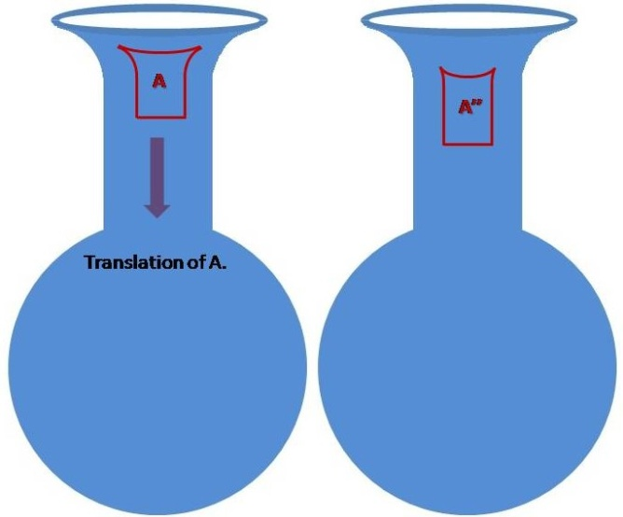
Figure 11. Original quadrilateral A (on the left), quadrilateral A'' translated vertically towards the generalized base (on the right). Source: the author.

Based on the reasoning shown above, it can be deduced what occurs when A is translated vertically in the opposite direction, towards the generalized summit. In the same way, it can be deduced what occurs for B.
Thus, we can conclude that the invariance of the figure by translation becomes a NeutroProperty since depending on the characteristics of S, the shape of the boundary curve between two regions, the position of the figure, and the direction of translation; it may be that the figure obtained by translation is either congruent or not to the original one. Undoubtedly, the invariance always manifests if the figure is contained entirely in a single region, H, P, or E. The translation may not maintain invariance when the figure has a non-empty intersection with two different regions.
To perform the rotation on S, this operation continues to satisfy all its properties as long as the figure is kept within one of the three subregions. To analyze what happens in one of the borders, let us again take quadrilateral A as an example. Suppose that figure A is rotated by an angle of 180º for the segment formed by the intersection of the border with the figure, where the turning point is the midpoint of this segment, which coincides with the axis of symmetry of the entire figure for the generalized legs, see Figure 12.

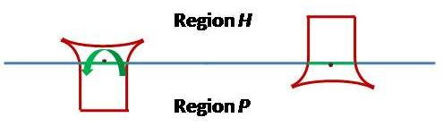
Figure 12. Quadrilateral A (on the left) is schematically represented in its original form. Quadrilateral A rotated 180º counter-clockwise if the rotation invariance hypothesis was true. The blue line represents the H-P boundary; the segment in green represents the spin segment. The black point is the midpoint of the segment for which the rotation is made. Source: the author.
Figure 12 visually shows the impossibility of performing this operation, if one takes into account that the segment through which the rotation is made divides the quadrilateral into two different quadrilaterals, which are a rectangle in the P region and a hyperbolic Saccheri quadrilateral in the H region. When making the 180º rotation, the rectangle lies in the H region and the Hyperbolic Saccheri quadrilateral in the P region, however, this is a contradiction, because the property of the sum of the interior angles of a quadrilateral is violated in both geometries. Therefore, in the case of region H, it is necessary to transform the lengths of the quadrilateral and also its interior angles. The same goes for the Saccheri quadrilateral which falls in the region P.
It is also not difficult to demonstrate that it is not always possible to carry out the reflection for a segment, for example, if the reflection is carried out for the borderline, it is evident that the figure obtained is reflected modified with the characteristics of the geometry where the reflected figure appears, for the same reason that we had argued for rotation. The classical properties of reflection hold for figures inside H, P, and E; for lines within these regions, so that they remain contained within the region.
One property that could be induced from viewing the images in Figure 10 is that if two Saccheri or Lambert quadrilaterals are joined at the boundary of two regions, each of which satisfies one of the three basic geometries, then a generalized Saccheri or generalized Lambert quadrilateral will be formed, respectively. This is false within the same region, except in Euclidean geometry, where the Saccheri and Lambert quadrilaterals are rectangles and the union of two rectangles forms a new rectangle. Theorem 1 establishes under what conditions this property is satisfied.
Firstly, we must clarify that we understand the union of two quadrilaterals when each leg of one quadrilateral intersects at a single point a leg of the other quadrilateral, so each leg of one of them is a prolongation of a leg of the other one.
Theorem 1. A generalized Saccheri or Lambert quadrilateral can always be formed from the union of two classical Saccheri or Lambert quadrilaterals, respectively, if and only if the legs of one of them can be extended by the legs of the other one and either:
- They are two quadrilaterals of Saccheri or Lambert of different basic geometries, or,
- They are two rectangles on a Euclidean surface.
Proof.
In the case of Euclidean geometry, it is trivial that the union of two Saccheri or Lambert quadrilaterals, which are rectangles, forms another rectangle, provided that both figures are conveniently joined.
When we deal with hyperbolic or elliptic geometries, there is a one-to-one relationship between the angle and the length; therefore, by extending the legs of Saccheri or Lambert quadrilaterals by the geodesics in hyperbolic or elliptical geometries, angles other than rights for the base will be obtained and therefore never a new generalized quadrilateral will be formed. See that whether it is a Lambert quadrilateral never the two summit angles will be right in non-Euclidean geometries, so the summit never will be the base of another quadrilateral of Lambert.
If through the boundary on the surface where two regions with different geometric characteristics meet, two Saccheri or Lambert quadrilaterals belonging to each geometry can be joined, as by definition the legs of each of the two quadrilaterals are contained in a geodesic within its region, then the union of the two pairs of legs between regions will be contained within a geodesic of the NeutroGeometrical surface.
Also, as by definition one of the two quadrilaterals has a base perpendicular to its legs, then this part of the definition for Saccheri and Lambert quadrilaterals will continue to hold. Also for Saccheri quadrilaterals, as pairs of legs with equal length are being joined, then the generalized legs obtained will also have the same length.
In the case of Lambert quadrilaterals, since the summit is perpendicular to one leg and the leg of the quadrilateral in the other region is perpendicular to its base, then the union of both quadrilaterals will form a generalized Lambert quadrilateral. The key to this property in hybrid geometries is that legs can be broken lines, so adjacent angles can be articulated independently of their measures.
As an example of this enlargement see Figure 13, where the surface S' is defined from the surface S by eliminating the subregion P and joining the subregions H and E. The figure shows the Saccheri and Lambert quadrilaterals generalized over them, which are formed as the union of two classical quadrilaterals in their respective geometries.

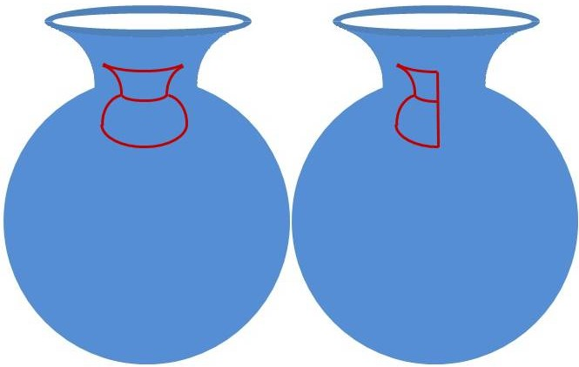
Figure 13. Surface S', generalized Saccheri quadrilateral (on the left), and generalized Lambert quadrilateral (on the right) on this surface. Source: the author.
Another example of a surface that satisfies NeutroGeometry is the sphere containing a cylinder-shaped hole; see Figure 14, where we also suppose the center of the sphere is included in the interior of the cylinder.

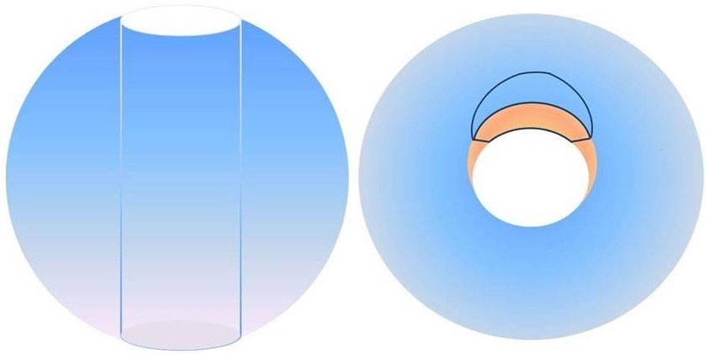
Figure 14. Surface built satisfying the NeutroGeometry (on the left). Generalized Saccheri quadrilateral on the surface (on the right). Source: the author.
The surface in Figure 14 has as its components both the spherical surface and the walls of the cylinder contained within. To the right of Figure 14, a Saccheri quadrilateral is delimited by dark lines, which is formed by a rectangle on the cylinder and also a quadrilateral on the sphere. This is an example of a surface where NeutroGeometry is satisfied with some elliptic and Euclidean elements. Moreover, interestingly some geodesic segments satisfy the axiom of hyperbolic parallelism, see Figure 15.

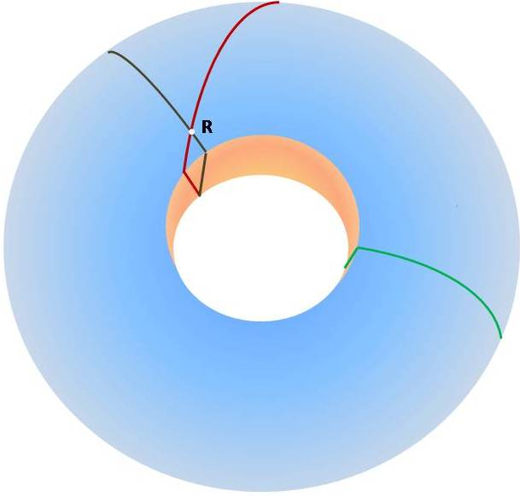
Figure 15. Surface S’ with three segments one of them has more than two parallel segments. Source: the author.
Figure 15 illustrates an example of two segments, those colored in red and black, passing for one point of intersection R, and which are parallels to the third segment in green. Thus, the surface also satisfies the property of parallelism of hyperbolic geometry for some segments.
Proposition 2. There are three segments on the surface S’ satisfying that two of them intersect at one point and a third one does not intersect with the others.
Proof.
Let us select any point R of S’ on the original sphere. Preferably we choose R near enough to the base of the cylinder, say with a distance ε>0. Now, let us choose two different points P₁ and P₂ contained in the original sphere but removed in S’. Also, these points must be on the base of the cylinder which is nearer to R, and such that their opposites were also removed from the sphere.
Now, let us draw three great circles on the original sphere, such that c₁ connects both, points R and P₁; c₂ connects both, points R and P₂ and c₃ connects both, points P₁ and P₂, see Figure 16.
c₁ in red and c₂ in black intersect only in R and its opposite on the sphere. c₃ in green does not have an intersection with c₁ or c₂, this is because the intersection of c₃ with c₁ is only P₁ and its opposite, but they were removed from S’, and the same reasoning is true for c₃ and c₂. See that on S’ the great circles which pass by the base of the cylinder can be extended by a straight line segment on the surface of the cylinder. The arcs of c₁ and c₂ that pass by the hole are not included, and we select from c₃ one of the arcs not passing by the hole, see again Figure 15 above.

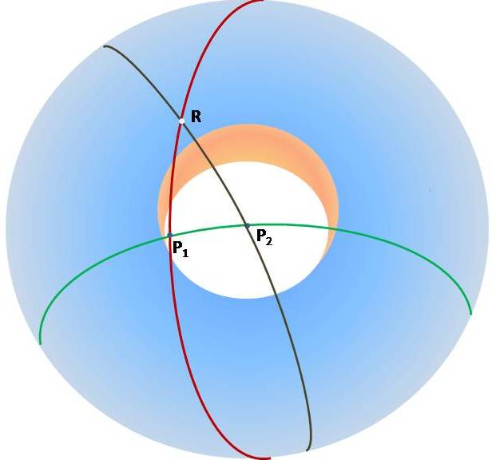
Figure 16. Visualization of the proof of Proposition 2. Source: the author.
On the other hand, great circles are still lines in the sphere where they do not intersect the cylinder. The surface of the cylinder has Euclidean properties, e.g., there is a rectangle in Figure 14 where the generalized Saccheri quadrilateral intersects this surface, and rectangles exist only in Euclidean geometry.
The previous examples are Smarandache Geometries which are also NeutroGeometries. The difference between NeutroGeometry and Smarandache Geometry is subtle. In NeutroGeometry we have to deal preferably with the information from reality, which not always corresponds to the ideality of classical geometries, and Smarandache Geometries are axiomatic approaches. Another difference is that NeutroGeometry is a logic-algebraic view of geometry because of its link with Neutrosophic logic, and Smarandache Geometry is mainly a purely geometrical approach.
Thus, let us illustrate this difference by using one example of a non-Smarandachean Neutrogeometry to prove that Neutrogeometry is the most general of these theories. For this end, let us consider a plane in Euclidean geometry representing the urban design of a certain city, see Figure 17.
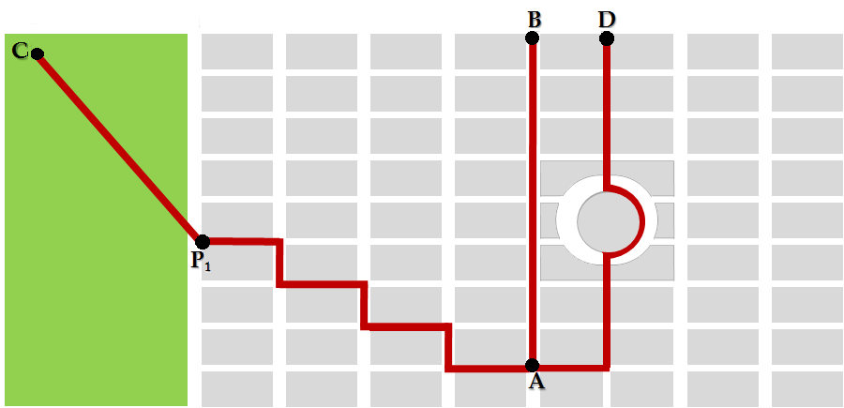
Figure 17. Euclidean model of an urban zone. The green space represents the urban zone and the gray rectangles and circle are the blocks. In green, we have a park in the city. Source: the author.
The smallest path from point A to point C is not a straight line, but a combination of a broken line with a straight line. Taking into account that straight lines are the only geodesics in Euclidean geometry and they must be the smallest trajectory between any two points, then the trajectory $\overline{AC}$ from A to C, is an indeterminate entity for the concept of the geodesic. See that this is not Mixed or Smarandache Geometry because none axiom is validated and invalidated; and neither axiom is invalidated in two ways, we are representing this scenario according to Euclidean geometry. On the other hand, we see that line $\overline{AB}$ is both a geodesic and a straight line according to the Euclidean axiomatic.
Thus, NeutroGeometry can also be obtained logically when there are lines that are not classified as geodesics but on the other hand, not always geodesics are straight lines. This is the result of the drawback of Euclidean geometry to represent some geometrical models.
Thus, Taxicab Geometry can be a solution to this problem [19]. This is a Euclidean geometry where the equation of distance between two points is changed to model urban zones. Considering a Cartesian coordinate system, where points E and F have coordinates $\left(x_{E},y_{E}\right)$ and $\left(x_{F},y_{F}\right)$ respectively, then $d_{P}\left(E,F\right)=\sqrt{{\left(x_{E}-x_{F}\right)}^{2}+{\left(y_{E}-y_{F}\right)}^{2}}$ of Pythagorean distance is substituted by the formula $d_{M}\left(E,F\right)=\left|x_{E}-x_{F}\right|+\left|y_{E}-y_{F}\right|$ of Manhattan distance. This geometric structure satisfies all Hilbert’s axioms of Euclidean geometry, except the axiom Size-Angle-Side of congruency of triangles, so, this is considered a non-Euclidean geometry.
Nonetheless, in this geometry the trajectory $\overline{AC}$ is not a geodesic, because of the straight segment contained in it. Neither the path like $\overline{AD}$ is a geodesic in Taxicab geometry, because it contains a circular segment in a Euclidean definition. So, even if we consider the model in Taxicab geometry, we will have that geodesic is a NeutroProperty.
From the results obtained so far, we deduce that Smarandache Geometry is defined from a surface of constant curvature, either null, positive or negative, from which a circle of a certain radius is eliminated.
Theorem 3. Let $S$ be a surface of constant Gaussian curvature $K$. There exists a real value $r>0$ such that a circle of radius $r$ is defined on $S$, let us call it $C$, where $S^{'}=S∖int(C)$ is a surface with characteristics of NeutroGeometry, especially Smarandache Geometry. Let us note that we only subtract the interior of the circle, but not the border.
Proof.
Let us take $r$ small enough, such that at least two certain points join a segment completely contained in $S^{'}$. So, these points satisfy the Axiom I in $S$.
On the other hand, if we take two points $P_{1}, P_{2}$ contained in the circumference of $C$, there is a segment in $C$, but not in $S^{'}$which joins both points. If by Axiom II this segment is extended to certain points $P_{1}^{'}, P_{2}^{'}∈S^{'}$, this segment is in $S$, but not in $S^{'}$. That is, some pairs of points satisfy Axiom I, while others do not, therefore Axiom I is a NeutroAxiom.
Furthermore, $S^{'}$ satisfies simultaneously at least two of the three axioms of parallelism. To prove it, let us take $r>0$ small enough such that there exists the axiom of parallelism corresponding to the geometry defined on $S$, depending on its curvature.
Firstly, let us suppose that $S$ has curvature $K≤0$. Let us take three ${Q_{1, }Q}_{2, }Q_{3 }$non-collinear points in $S$, where ${Q_{1, }Q}_{2 }$ are contained in the boundary of the circle $C$ and $Q_{3 }∈S∖C$.
These three points can be conveniently determined such that both, segments $\overline{Q_{1}Q_{3 }}$and $\overline{Q_{2}Q_{3 }}$, are formed. See Figure 18.
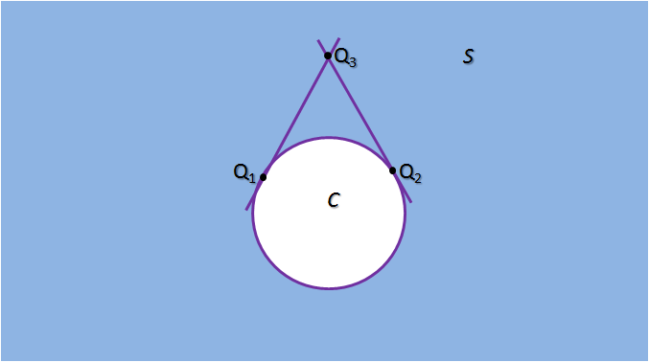
Figure 18. Generic representation of the surface $S$, the circle $C$ and the points ${Q_{1, }Q}_{2, }Q_{3 }$with the segments $\overline{Q_{1}Q_{3 }}$ and $\overline{Q_{2}Q_{3 }}$. Source: the author.
It is evident that $\overline{Q_{1}Q_{3 }}$ and $\overline{Q_{2}Q_{3 }}$ are tangent to the circle $C$. That is why the segment $\overline{Q_{1}Q_{3 }}$ does not have a parallel line that passes through the exterior point $Q_{2}$, since $Q_{2}Q_{3 }$ is the only line passing by $Q_{2}$ and contained in $S^{'}$, and $\overline{Q_{1}Q_{3 }}$ and $\overline{Q_{2}Q_{3 }}$ are not parallels. Therefore, in $S^{'}$ some lines satisfy the axiom of parallelism proper to $S$ (with at least one line parallel to another one passing through an exterior point), and at the same time some line that does not have any parallel that passes through an exterior point to it.
If $S$ has constant positive curvature, the proof of Proposition 2 is reproduced.
Thus in any case the axiom of parallelism is also a NeutroAxiom.
Remark 2. This theorem remains valid when the hypotheses are generalized in several ways. For example, when more than one set in the form of a circle is eliminated from the geometric space, when the circle of the theorem is replaced by a set delimited by some other bounded and closed curve, or when the geometry is defined on a surface S of non-constant curvature with the same sign.
From the previous results, it can be intuitively ensured that Smarandache Geometry or NeutroGeometry defined as Theorem 3 or Remark 2 corresponds to situations where there are obstacles of any kind that prevent the joining of any two points. Examples of this had already been treated as transit through an urban area where we can only go through the path traced by the streets, where these streets have different shapes, such as rectangular, square, triangular, circular, oval, among others. Also, whether we need to fly in a plane along a certain route and a deviation from the terrestrial geodesic is recommended due to the existence of some turbulent zone that may exist on the trajectory, when we have to travel from one point to another in a geography that has a desert or a volcanic area that is recommendable to avoid, among many other situations where none of the classical geometries offers a model that is effectively applied to the real condition.
That is why the geodesic lines are not those recommended for a specific geometry, for example, the line that joins points A and C or A and D in Figure 17 are not the straight lines of Euclidean geometry, nor the lines defined in the Taxicab geometry.
However, in this paper we propose the notions of distance and area in Smarandache Geometry or a NeutroGeometry as the decomposition of the distance and area formulas depending on the region in which we find ourselves.
A common characteristic of the distance between any two points in any geometry is that it is a positive real value such that intuitively it is associated with the minimum path to join both points. That is why if $P$ and $Q$ are two points in the Smarandachean Geometry then:
$d_{Sm}\left(P,Q\right)=d_{G_{0}}\left(P,P_{1}\right)+\sum_{i=1}^{n-2}{d_{G_{i}}\left(P_{i},P_{i+1}\right)+}d_{G_{n}}\left(P_{n-1},Q\right)$ (1)
This is interpreted as that given the region $R$, which is divided into subregions $R_{G_{i}}$ according to certain geometries $G_{i}$ with $0≤i≤n$, where ${P∈R}_{G_{0}}$ and ${Q∈R}_{G_{n}}$, such that $d_{Sm}\left(∙,∙\right)$ denotes the distance in the Smarandache Geometry, while $\overline{PP_{1}⋯P_{n-1}Q}$ is the path from $P$ to $Q$ such that $P_{1},⋯,P_{n-1}$ are the points on the border between $G_{i-1}$ and $G_{i}$ where the minimum trajectory is reached according to the distance $d_{G_{i}}\left(P_{i},P_{i+1}\right)$ of such geometry.
For example, in Figure 17 the path with the shortest distance from A to C is $\overline{AP_{1}C}$, which is why the distance $d_{Sm}\left(P,Q\right)=d_{Manhathan}\left(A,P_{1}\right)+d_{Pythagorean}\left(P_{1},C\right)$. It is easy to prove that $d_{Sm}\left(P,Q\right)$ satisfies the definition of distance.
The area of a figure is also a positive real-valued function that is additive in all geometries. In other words, for $R=R_{0}∪R_{2}∪⋯∪R_{n}$, such that $∀i,j∈\left\{0,1,2,⋯,n\right\}$ with $i≠j$, it is fulfilled that $R_{i}∩R_{j}=∅$ then the area of $R$ is defined as $A\left(R\right)=\sum_{k=0}^{n}{A\left(R_{k}\right)}$.
In the case of Smarandache Geometry, we define:
$A_{Sm}\left(F\right)=\sum_{k=0}^{n}{A_{G_{k}}\left({F∩R}_{G_{k}}\right)}$ (2)
That is, the area $A_{Sm}$ of a two-dimensional figure $F$ is the sum of the areas of the subsets of $F$ corresponding to each of the geometries in each subregion $R_{G_{k}}$.
E.g., Saccheri Quadrilateral in Figure 14 is calculated as the area of the quadrilateral embedded in the cylindrical surface that corresponds to a Euclidean geometry added with the area of the quadrilateral on the sphere that corresponds to spherical geometry.

Discussion
One of the limitations that exists in the credibility of the usefulness of developing a theory such as NeutroGeometries and AntiGeometries is the lack of models in real life or at least constructed, but visually simple enough to meet the characteristics of NeutroGeometry or AntiGeometry. Existing models are scarce, possibly Bhattacharya's is the only one, which despite clearly fulfilling all the conditions of a NeutroGeometry, seems disconnected from any two-dimensional body or figure that is recognizable to us. Other attempts can be read in the very recent work of C. Granados [20]. This happens because we know from experience that Euclidean geometry has a very wide range of applicability, which has allowed its establishment and acceptance as one of the most solid branches of mathematics, to the point that for many centuries it was considered the only possible geometry.
This article is the result of investigating objects or bodies that exist in the universe that respond to this new theory. To this end, we have shown images of such artificial objects, animals, or celestial bodies that do not respond in a pure way to the axiomatic of one of the three basic geometries, Euclidean, Hyperbolic, or Elliptical. For example, an octopus, if its surface is studied, responds to characteristics of elliptic geometry if we analyze the geometric characteristics of its head, or hyperbolic if the geometrical characteristics of the membrane that joins its tentacles are analyzed.
However, we must note the work of H. Iseri with its manifolds with characteristics of Smarandache Geometry, which are types of NeutroGeometries. Nor can we categorically affirm that there were no previous examples of the practical application of NeutroGeometries, such as the one that appears in Figure 19, which contains the images of a river where it is not true that any two points on it can be connected by a line, because this is not navigable, therefore this axiom does not hold. However, practical examples in this regard are also scarce.
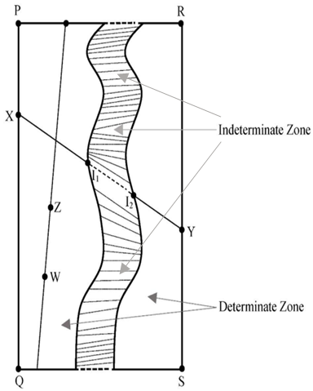
Figure 19. Map of non-navigable river. Example of AntiGeometry taken from reality. Source [12].
Among the contributions of this article, we have the description of surfaces where the requirements of being a NeutroGeometry are met based on the well-known relationship between the sign of the curvature of a surface and the type of geometry. Even artificially constructed surfaces look like objects from everyday life to any person.
Deepening even more in the characteristics of a NeutroGeometry that satisfies that it is divided into two or three regions where each one of them responds to one of the three basic geometries, we have carried out a practical study of the characteristics of two-dimensional geometrical figures, to which we have defined for the first time and that we have called the generalized Saccheri quadrilateral and the generalized Lambert quadrilateral. If each region meets the characteristics of one of the three basic geometries, the generalized Saccheri or Lambert quadrilaterals will continue to meet their characteristics within each of these geometries.
However, we have shown that when these two figures contain non-empty intersections with two regions on the surface, each one with different geometric characteristics, then it is generally not possible to maintain the invariance that has always been satisfied by any figure within the basic geometries when performing translation, rotation, or reflection. This property is important to know when it comes to studying the movement of a figure on a given surface, which implies that we will not always be able to carry out these movements without modifying the original shape of the figure.
On the other hand, we have proved a theorem of a property that holds for NeutroGeometries and not for basic geometries, except Euclidean, such that two Saccheri or Lambert quadrilaterals of two different geometries can be joined to form a generalized one, provided that one can be prolonged in the other. Two rectangles can be joined to form another rectangle, but two hyperbolic or elliptic Saccheri or Lambert quadrilaterals cannot be joined to form a new hyperbolic or elliptic quadrilateral, respectively. This means that we have found an invariance property between two regions with different basic geometries.
In addition to all this, this study is an axiomatic approach to geometric theory from the classical point of view, without the need to consider the surface as a locus with changes in curvature and therefore where only makes sense local inner metric, where there is a biunivocal relationship with Euclidean geometry as occurs with the Riemannian manifolds. Although the solution given by Riemann to this problem and which gives way to Differential Geometry is of great importance for mathematics and is a more general solution to that given by the NeutroGeometries.
If we had to admit some limitations of the approach from the NeutroGeometries that appear in this paper, it is first of all how to approach axiomatically the cases of surfaces where there are changes in curvature, where there are not even well-defined regions such as those shown by us in this investigation. The answer to this would be to apply Riemann's or even Iseri’s theory of manifolds.
The other limitations are related to the scope of this work, for example, it is necessary to define three-dimensional or higher-dimensional bodies and not only surfaces that satisfy the characteristics of a NeutroGeometry. Nor theoretical models of NeutroGeometries have been proposed where lines that pass through infinity appear, instead of bounded surfaces, and their relationship with already known models such as the Poincaré disk or the elliptical geometry sphere. Also, we can extend the fuzzification to the neutrosophic logic of the Euclidean geometric axiomatic in the sense of [21], which basically we admit that in geographical frameworks there are drawbacks in the crisp axiomatic theory. All this constitutes the material for future research.

Conclusions
In this article, we have approached the practical study of NeutroGeometries and AntiGeometries as well as Smarandachean Geometries, to demonstrate and illustrate the existence of elements of real life that must be studied from these new theories, because the traditional ones are not enough accurate. Real objects are not purely Euclidean, hyperbolic, or elliptical, but a combination of them. For this, we have illustrated the behavior of the Saccheri and Lambert quadrilaterals within these surfaces, where we can conclude that it is at the border of two regions with different geometric characteristics where some properties are not 100% fulfilled, specifically the invariance of translation, rotation, or reflection of figures lying on the surface and having one part satisfying one axiomatic and another part satisfying another. We also proved a theorem where two Saccheri or Lambert quadrilaterals can be joined, each on a different geometry, to form a new generalized quadrilateral, which is not valid in either hyperbolic or elliptic geometry for Saccheri or Lambert quadrilaterals.

Conflicts of Interest
The author declares that there is no conflict of interest regarding the publication of this paper.

References
- N.V. Efimov, Geometría Superior (Higher Geometry)(Translated to Spanish); Editorial Mir, Moscow, USSR, 1984.
- J. Gray, Worlds Out of Nothing. A Course in the History of Geometry in the 19th Century, Springer-Verlag, London, UK, 2007.
- H. Struve and R. Struve, “Non-Euclidean geometries: the Cayley-Klein approach,” Journal of Geometry, vol. 98, no. 2010, pp. 151–170, 2010.
- J. Richter-Gebert, Perspectives on Projective Geometry. A Guided Tour through Real and Complex Geometry, Springer-Verlag, Berlin Heidelberg, Germany, 2011.
- J.L. Marques Barbosa, Geometria Hiperbólica (In Portuguese); IMPA, Rio de Janeiro, Brazil, 2007.
- M. Hvidsten, “Foundations of Elliptic Geometry”. In Exploring Geometry-Web Chapters; Available online: URL: Geometryhomepages.gac.edu/∼hvidsten/geom.-text/web-chapters/elliptic.pdf (accessed on 16/09/2022).
- C. Goodman-Strauss, “Compass and Straightedge in the Poincaré Disk,” The Mathematical Association of America, vol. 108, no. 1, pp. 38-49, 2001.
- R. Patmaningrum and H.P. Lestari, “Polygons in hyperbolic geometry using Beltrami-Klein models,” Journal of Physics: Conference Series, vol. 1581, no.1, pp. 12-53, 2020.
- R. Coghetto, “Klein-Beltrami model. Part III,” Formalized Mathematics, vol. 28, no. 1, pp.1-7, 2020.
- A. Pressley. Elementary Differential Geometry, Springer-Verlag, London, U.K., 2001.
- H. Iseri, “Partially Paradoxist Smarandache Geometries,” Smarandache Notions Journal, vol. 13, no. 1-2-3, pp. 5-13, 2002.
- F. Smarandache, “NeutroGeometry & AntiGeometry are alternatives and generalizations of the Non-Euclidean Geometries (revisited),” Neutrosophic Sets and Systems, vol. 46, no. 2021, pp. 456-477, 2001.
- P.K. Singh, “Anti-Geometry and NeutroGeometry Characterization of Non-Euclidean Data,” Journal of Neutrosophic and Fuzzy Systems, vol. 1, no. 1, pp. 24-33, 2021.
- L.J. Hernández Paricio, E. Malinova Letkova and M.T. Rivas Rodríguez, Geometría Plana Neutral (In Spanish) University of La Rioja, Logroño, Spain, 2021.
- P. Kelly and G. Matthews, The Non-Euclidean Hyperbolic Plane. Its Structure and Consistency, Springer-Verlag, New York, USA, 1981.
- S.G. Taherian and M. Rostamzadeh, “Defect and area in Beltrami-Klein model of hyperbolic Geometry,” Proceedings of 43rd Annual Iranian Mathematics Conference, University of Tabriz, Tabriz, Iran, pp. 27-30, August 2012.
- H. Iseri, Smarandache manifolds, American Research Press, Rehoboth, NM, USA, 2002.
- S.A. Bhattacharya, “A Model to the Smarandache Geometries,” Journal of Recreational Mathematics, vol. 33, no. 2, pp. 166-166, 2004.
- E.F. Krause, Taxicab Geometry. An Adventure in Non-Euclidean Geometry, Dover Publications, New York, USA, 1986.
- C. Granados, “A note on AntiGeometry and NeutroGeometry and their application to real life,” Neutrosophic Sets and Systems, vol. 49, no. 2022, pp. 579-592, 2022.
- A. Tserkovny, “Fuzzy Logic for Incidence Geometry,” The Scientific World Journal, vol. 16, pp. 9057263-9057263, 2016.

